Ashley McGuire

4/7/2021

BIO 202

**The Gastrointestinal Tract**

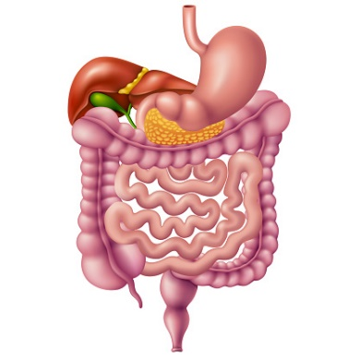

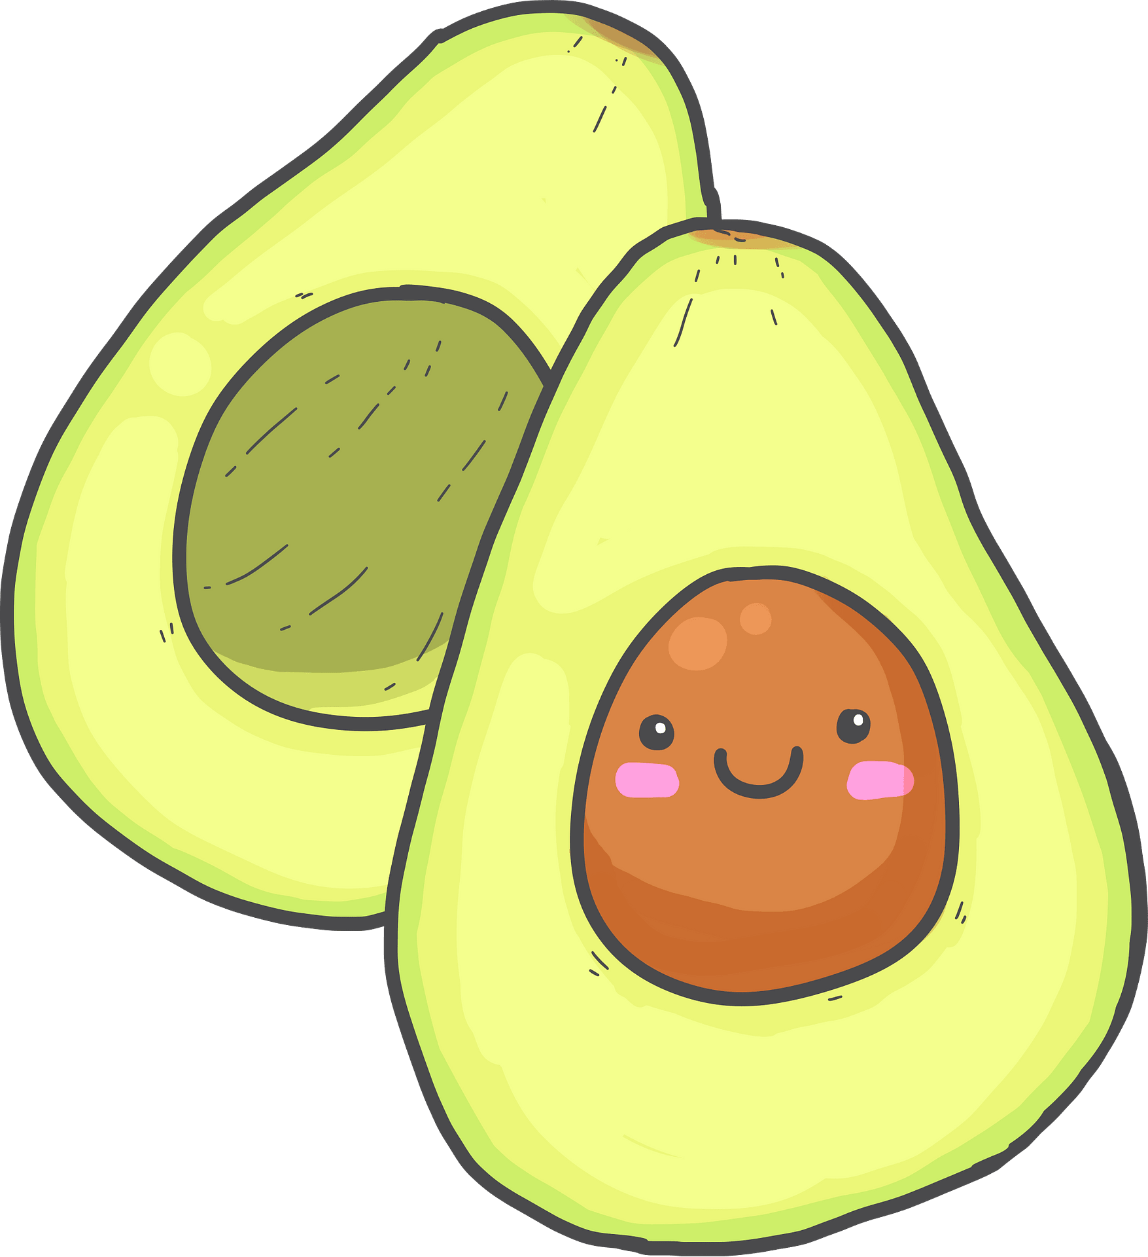 Avocado is one of my favorite foods on the planet!

This delightful green fruit is mainly composed of fat macromolecules, so lipids are what are going to be prominent in the digestion process. Lipids being the consideration, lipase will be the matching enzyme.

Digestion overview:

Our digestive system runs from our mouth, all the way to the anus. Anything that is ingested, but not absorbed by the small intestines or stomach, it is said to be in the alimentary canal. The digestive process includes six essential activities: ingestion, propulsion, mechanical breakdown, digestion, absorption, and defecation. Food is first taken in by ingestion. Chewing occurs for mechanical breakdown of the food into small components. Swallowing in the oropharynx pushes the food further down the gastrointestinal tract via propulsion. Propulsion further occurs in the pharynx and esophagus. Peristalsis throughout the esophagus, stomach, and intestines propel the food down into the lower gastrointestinal tract to prepare for digestion. The food is then churned in the stomach for mechanical digestion and segmentation occurs in the small intestine. Nutrients are absorbed by the lymph and blood vessels. Whatever is not absorbed is made into feces, mainly water, and defecation occurs via the anus.

The gastrointestinal tract has the same basic tissue layout all throughout the alimentary canal. A mucosal layer lines the lumen. This is surrounded by the muscularis, which is smooth muscle, and then there is the outer serous layer, which is connective tissue. The mucosa secretes enzymes, such as in the small intestine and stomach. Mucus also helps food pass through the tract. The lamina propria, just deep to the epithelia layer, assists in food absorption. The muscularis externa is what is responsible for segmentation and peristalsis in digestion.

The journey of an avocado’s digestion begins when external stimuli, such as the sight of the bright green coloration, signals the neurons to ready the stomach for eating, also known as long reflexes sent by the central nervous system. The extrinsic visceral, or autonomic, efferents activate the local nerve plexus, or “gut brain” to stimulate the effector muscles to change in contractile or secretory activity. The cephalic (reflex) phase of gastric secretion regulation is also triggered by the aroma, taste, sight, thought of the avocado.

When the creamy avocado is put into the oral cavity and the stomach is stretched, this stimulates short reflexes to secrete gastric juices and gastric motility. Chemoreceptors, osmoreceptors, and mechanoreceptors tell the local nerve plexus to trigger the effector muscles to change in contractile or secretory activity.

As the avocado enters the mouth and goes past the teeth, the mechanical digestion of chewing and grinding by the teeth breaks it down into smaller pieces. Incisors cut, canines tear or pierce, premolars (bicuspids) grind and crush, and the molars grind. The hard palate helps create friction against the tongue and the soft palate closes off the nasopharynx during swallowing with the help of the uvula to make sure all the delicious avocado continues down the right way. The tongue repositions and mixes the avocado during chewing and forms a bolus from the avocado. Lingual lipase is secreted by serous cells beneath foliate and vallate papillae secrete fat-digesting enzyme that is functional in the stomach.

Major salivary glands are activated by parasympathetic nervous system when the avocado stimulates chemoreceptors and mechanoreceptors in mouth leading the salivatory nuclei in the brain stem to send impulses along parasympathetic fibers in cranial nerves VII and IX. Saliva cleanses the oral cavity, dissolves the chemicals so that you can taste the delicious avocado, moistens the avocado to make it easier to move down the gastrointestinal tract, and begins any starch breakdown. The parotid duct opens into oral vestibule next to second upper molar, the submandibular duct opens at base of lingual frenulum, and the sublingual gland opens via 10–12 ducts into floor of mouth. The swallowing process is then initiated.

During the buccal phase of swallowing, the upper esophageal sphincter is contracted. The tongue presses against the hard palate, forcing the food bolus into the oropharynx. The pharyngeal-esophageal phase begins as the uvula and larynx rise to prevent the avocado from entering respiratory passageways. The tongue blocks off the mouth and the upper esophageal sphincter relaxes, allowing the avocado to enter the esophagus. The constrictor muscles of the pharynx contract, forcing the avocado into the esophagus inferiorly. The upper esophageal sphincter contracts after the avocado enters. Peristalsis moves the avocado through the esophagus and into the stomach. The gastroesophageal sphincter surrounding the cardial oriface opens, and the avocado enters the stomach.

Lipid digestion essentially begins in the stomach with the aid of lingual lipase and gastric lipase. The gastrocolic reflex is initiated by presence of the avocado in the stomach and activates three to four slow powerful peristaltic waves per day in colon, also known as mass movements. The upper left quadrant serves as temporary storage and digestion of bolus to chyme occurs. The mucosa of the stomach secretes a two-layer coat of alkaline mucus and the surface layer traps bicarbonate-rich fluid beneath it. It is also dotted with gastric pits, which lead to gastric glands and the gastric glands produce gastric juice. Glands in fundus and body of the stomach produce most of the gastric juice. The gastric phase begins at this point and lasts 3–4 hours where ⅔ gastric juice released. It is stimulated by distension, peptides, low acidity, gastrin (major stimulus). Enteroendocrine G cells are stimulated by caffeine, peptides, rising pH and leads to gastrin.

Lipases from the chief cell secretions digest approximately 15% of the lipid. Intrinsic factor secretion is also a vital function of the stomach. This is a glycoprotein required for absorption of vitamin B12 in small intestine. Enteroendocrine cells secrete chemical messengers into lamina propria, which act as paracrines - serotonin and histamine. Somatostatin, which also acts as paracrine, is secreted along with gastrin. The mucosal barrier, a thick layer of bicarbonate-rich mucus with tight junctions between epithelial cells, prevents the gastric juice from seeping underneath tissue. Mechanical breakdown in the stomach continues. Proteins are denatured by HCl and enzymatic digestion of proteins by pepsin occurs. The avocado then enters the cardia, then into the fundus below the diaphragm and into the body. Propulsion occurs and peristaltic waves move from the fundus toward the pylorus. The pyloric part is the next step of the journey. The antrum, or superior portion, leads into the pyloric canal and into the pylorus. The pylorus is continuous with the duodenum through pyloric valve, which is the sphincter controlling stomach emptying. Distension and gastrin increase the force of contraction to move the avocado. Grinding occurs, which is the most vigorous peristalsis and mixing action occur close to the pylorus. Retropulsion occurs, which is when the pyloric end of the stomach acts as a pump that delivers small amounts of chyme into the duodenum, simultaneously forcing most of its contained material backward into the stomach. Chyme is either delivered in approximately 3 ml spurts to duodenum, or forced backward into stomach.

As chyme enters duodenum, receptors respond to stretch and chemical signals. The intestinal phase of gastric secretion and regulation begins when the avocado in the duodenum inhibits gastric secretion. Enterogastric reflex and enterogastrones also inhibit gastric secretion and duodenal filling. Duodenal (Brunner's) glands of the duodenum secrete alkaline mucus to neutralize acidic chyme. When chyme enters the duodenum, the hormonal responses trigger release of bile, which is produced in the liver and stored in the gallbladder. Chyme entering the duodenum causes duodenal enteroendocrine cells to release cholecystokinin (CCK) and secretin. Fatty chyme, such as from the avocado, remains in the duodenum 6 hours or more. CCK and secretin enter the bloodstream. CCK induces secretion of enzyme-rich pancreatic juice. Secretin causes secretion of HCO3− -rich pancreatic juice. Bile salts and, to a lesser extent, secretin are transported via the bloodstream to stimulate the liver to produce bile more rapidly. CCK via the blood stream causes the gallbladder to contract and hepatopancreatic sphincter to relax. Bile enters the duodenum. During cephalic and gastric phases, vagal nerve stimulates the gallbladder to contract weakly. The bile duct, from the liver and main pancreatic duct join at hepatopancreatic ampulla, enter the duodenum at the major duodenal papilla. This entry is controlled by the hepatopancreatic sphincter.

The bile secreted by the liver aids in the digestion of lipids (triglycerides) by emulsification. Emulsification is a process where large lipid globules are broken down into smaller lipid globules. These small globules are widely distributed in the chyme rather than forming large aggregates. Lipids are hydrophobic substances: in the presence of water, they will aggregate to form globules to minimize exposure to water. Bile contains bile salts that contain hydrophobic and hydrophilic parts. The bile salts hydrophilic side can interface with water on one side and the hydrophobic side interfaces with lipids on the other. By doing so, bile salts emulsify large lipid globules into small lipid globules. Pancreatic juices contain enzymes called lipases. Amylase, lipases, nucleases are secreted from pancreatic juices in active form but require ions or bile for optimal activity. If the lipid in the chyme aggregates into large globules, very little surface area of the lipids is available for the lipases to act on, leaving incomplete digestion of the lipid. By forming an emulsion, bile salts increase the available surface area of the lipids. The pancreatic lipases can then act on the lipids more efficiently and digest them. Lipases break down the lipids into fatty acids and glycerides. These molecules can pass through the plasma membrane of the cell and enter the epithelial cells of the intestinal lining. The bile salts surround long-chain fatty acids and monoglycerides forming tiny spheres called micelles. The stomach then delivers chyme to small intestine.

Most lipid digestion occurs in the small intestine due to pancreatic lipase. The small intestine subdivides into the duodenum (retroperitoneal), jejunum (attached posteriorly by mesentery), and ileum (attached posteriorly by mesentery). Circular folds in the small intestine force chyme to slowly spiral through the lumen, leading to increased nutrient absorption to make sure your body gets all of that potassium and other vitamins, minerals, and electrolytes from the avocado. Villi are extensions of mucosa with capillary bed and lacteal for absorption. Microvilli, or the brush border, contain enzymes for carbohydrate and protein digestion, but lipids are really the main consideration with the avocado. The micelles from the previously mentioned bile salts move into the brush border of the small intestine absorptive cells where the long-chain fatty acids and monoglycerides diffuse out of the micelles into the absorptive cells leaving the micelles behind in the chyme. The long-chain fatty acids and monoglycerides recombine in the absorptive cells to form triglycerides, which aggregate into globules and become coated with proteins. These large spheres are called **chylomicrons**. Chylomicrons contain triglycerides, cholesterol, and other lipids and have proteins on their surface. The surface is also composed of the hydrophilic phosphate “heads” of phospholipids. Together, they enable the chylomicron to move in an aqueous environment without exposing the lipids to water. Chylomicrons leave the absorptive cells via exocytosis. Chylomicrons then enter the lymphatic vessels and enter the blood via the subclavian vein. Secretory cells that produce intestinal juice are released by the intestinal crypts of the small intestine. The intestinal juice then facilitates transport and absorption of nutrients from the avocado. Segmentation is a motion of small intestine, initiated by intrinsic pacemaker cells. This process mixes and moves the contents of the avocado towards the ileocecal valve. Intensity of segmentation is altered by long & short reflexes and hormones. Parasympathetic increases this and sympathetic decreases it. It wanes in the late intestinal, or fasting, phase. Peristalsis is initiated by the rise in hormone *motilin* in the late intestinal phase and happens every 90–120 minutes. Each wave starts distal to previous. The avocado remnants, bacteria, and debris are moved to large intestine. Ileocecal sphincter relaxes, admits chyme into large intestine when the gastroileal reflex enhances force of segmentation in ileum. Gastrin increases motility of ileum and the ileocecal valve flaps close when chyme exerts backward pressure. The avocado will now enter the large intestine by peristalsis.

The cecum is the first part of large intestine and the appendix includes masses of lymphoid tissue. The appendix is the bacterial storehouse that recolonizes the gut when necessary. Twisted section allows enteric bacteria accumulate and multiply. The avocado then enters the colon. Haustral contractions, which are slow segmenting movements where the haustra sequentially contracts in response to distension, move the avocado through the colon. The ascending colon, right side to the level of the right kidney is the first stop for the avocado in the colon. This section then leads to the right colic (hepatic) flexure. The avocado goes to the transverse colon and into the left colic (splenic) flexure. The avocado then travels through the descending colon on the left side and into the sigmoid colon in the pelvis. This is where the remnants of the avocado will enter the rectum. The anal canal is the last part of the colon and will take the avocado to the anus for defecation. Defecation is a series of mass movements that force feces, also known as leftover avocado, toward the rectum. Distension initiates the spinal defecation reflex via parasympathetic signals. Feces moves into and distends the rectum, stimulating stretch receptors there. The receptors transmit signals along afferent fibers to spinal cord neurons. A spinal reflex is initiated in which parasympathetic motor (efferent) fibers stimulate contraction of the rectum and sigmoid colon, and relaxation of the internal anal sphincter. If it is convenient to defecate, voluntary motor neurons are inhibited, allowing the external anal sphincter to relax so feces may pass.